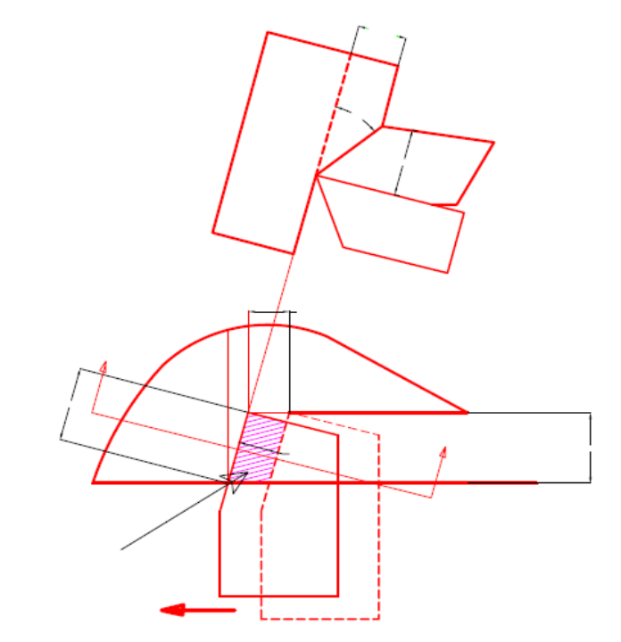
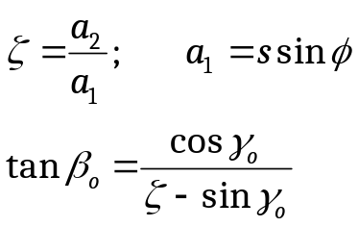
a₁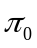
a₂
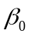
s

b₁

a₁
t
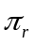
A_{ch}

Reports:

- Indicate the observed features of the collected chips in the following tabular forms:

Sl No | Vc | S | Chips |  | a2 |  |  | Remarks
Sl No | Vc | S | Color | Form
1 | 60 | 0.16
2 | 80 | 0.16
3 | 100 | 0.16
4 | 120 | 0.16
5 | 100 | 0.08
6 | 100 | 0.12
7 | 100 | 0.16
8 | 100 | 0.20

- Graphical plots showing the effects of variation of Vc, S and cutting fluid application on the value of and .

- Remarks on the overall observations.

Department of Mechanical Engineering
Indian Institute of Technology Kharagpur

Machine Tools and Machining Laboratory
(Laboratory assignments)

Study of mechanism and morphology of chip formation under
Different machining (turning) conditions.

Theory:
Morphology and mod of formation of chips are quite important indices to judge machinability characteristics of any work-tool combination under given machining conditions. All the parameters involved in machining play significant roles on such machinability characteristics.

Experiment:

Process--straight turning
Work material – C60 steel
Tool insert—P30, SPUN carbide inserts.

Process parameters:

Cutting velocity,Vc-60 to 120 m/min (choose 60,80,100&120 m/min
Feed, S-- 0.20 mm/rev
Depth of cut, - 2mm.
Environment – Dry and soluble oil.

Procedural steps:

- Measure the work piece diameter and note down the available speed – feed
combination
- Calculate and set appropriate rpm of the spindle using variable spindle drive.
- Collect chips after a few seconds of machining
- Note color and form of the chips.
- Measure the average thickness(a2) of the chips.
- Determine the value of chip reduction coefficient () and shear angle() for all the machining conditions.

